Gerardo Daniel Naranjo Gallegos, A01209499

Robotic Vision

Assignment 02

Due: 5-Feb-2019

**Different types of graphic file extensions**

Contenido

Introduction: 2

Objective: 2

Search Source: 2

Upload the following to your assignments folder: 2

Solution: 3

JPG file: 3

PPM file: 3

BMP files: 4

TIF files: 5

Referencias 6

# Introduction:

* Graphic file extensions vary with several types such as: *.jpg, *.ppm, *.bmp, *.png, *.tif, *.gif, etc.

# Objective:

* Find out how the following graphic files are represented and stored in a Hard Drive: *.bmp, *.tif, *.jpg and *.pgm.
* Include a full explanation of the sections found in the graphic format and how values for each pixel are stored. Also state how a particular pixel can be located within the file.

# Search Source:

* The Internet and/or a textbook

# Upload the following to your assignments folder:

* A word document containing the explanation for each graphic format.
* Include references in your document.

# Solution:

## JPG file:

The following table shows the metadata structure:

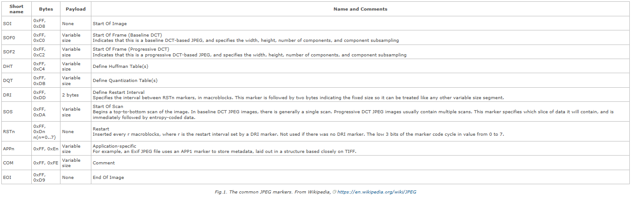

(Jean-Philippe Lang, 2012)

## PPM file:

The PPM file supports colors. Consist basically in two parts, header and image data. The header has a “magic number”, which is an identifier of the format; the “magic number” is not a number is more like a string of the type: “P6512 512 256”. For example, the P1 and P4 indicates bitmap (PBM files), P2 and P5 is used for gray scale image (PGM files) and P3 and P6 indicates full color image (like PPM). (Simple Image File Formats, 2009)

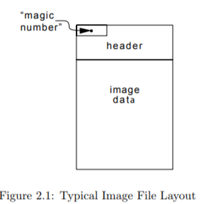

## BMP files:

The header contains info about the type, size, and layout service.

The info header specifies the dimensions, compression type and color format.

The color table have the RGB (24 bit) information.

The pixel data is an array of bytes that defines the bitmap bits.

All of this can be more detailed in the next table:

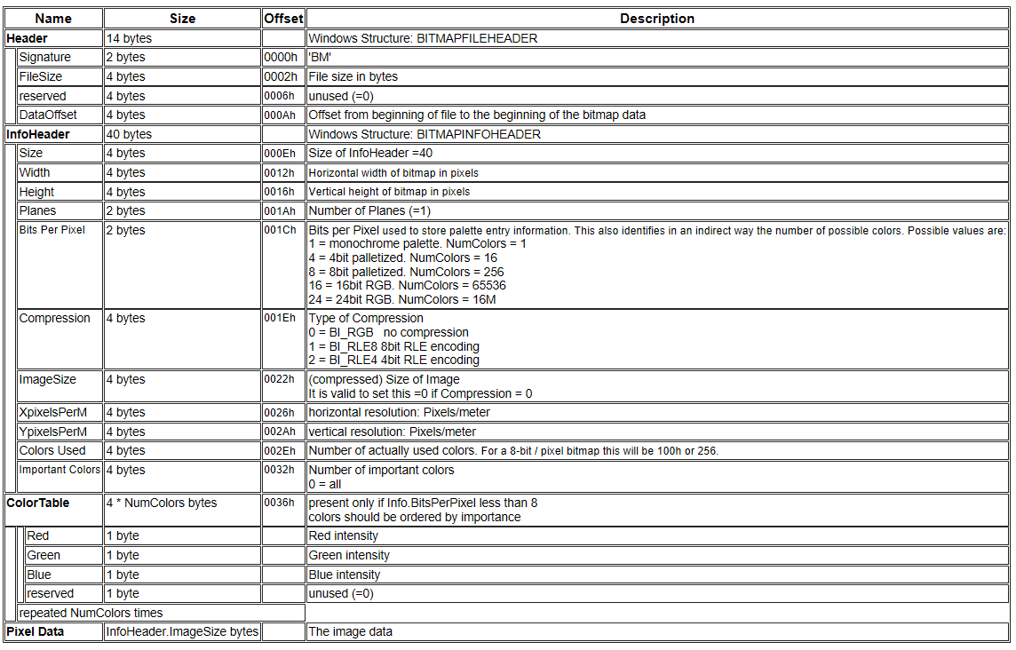

Table 1. BMP format.

(Nathan Liesch, 2003)

## TIF files:

These files correspond to the name of Tag Image File Format (TIFF). All the TIF files starts with the header structure, which consist of: the ID: the identification can be II for Intel byte or MM for Motorola byte; second, the TIFF version number: this value never changes and it is 42; finally, the offset of first image file directory (IFD), for more information we can check the figure 4.2. (Aware Systems, s.f.)

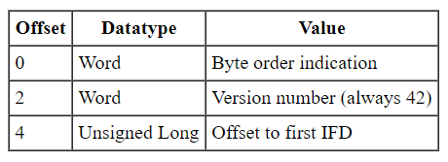

Figure 4.1. File header for TIF files.

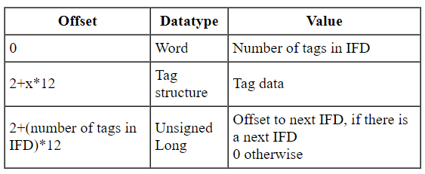

Figure 4.2. IFD for TIF files.

# Referencias

Aware Systems. (n.d.). *TIFF, Tag Image File Format, FAQ*. Retrieved from AWARE [SYSTEMS]: https://www.awaresystems.be/imaging/tiff/faq.html

Jean-Philippe Lang. (2012). *The Metadata in JPEG files*. Retrieved from Exiv2 @ Redmine: http://dev.exiv2.org/projects/exiv2/wiki/The_Metadata_in_JPEG_files

Nathan Liesch. (2003). *THE BMP FILE FORMAT*. Retrieved from http://www.ece.ualberta.ca/~elliott/ee552/studentAppNotes/2003_w/misc/bmp_file_format/bmp_file_format.htm

*Simple Image File Formats*. (2009, 11 13). Retrieved from people.cs.clemson.edu: https://people.cs.clemson.edu/~dhouse/courses/405/notes/ppm-files.pdf